SAMPLE SUBMISSION
Integrative Programming 1 — Semi-Final Examination
Student Name: | Cyle Stephen
Family Name: | Marquiso
Database File: | marquiso.db
Table Prefix: | marquiso_
Subject: | Integrative Programming 1
Topic: | SQLAlchemy + Alembic Data Migrations
Date: | March 30, 2026

Screenshot 1 — Database File Location

The student navigates to their project directory and confirms the presence of delacruz.db using ls -lh. The find command is also shown to pinpoint the absolute path.
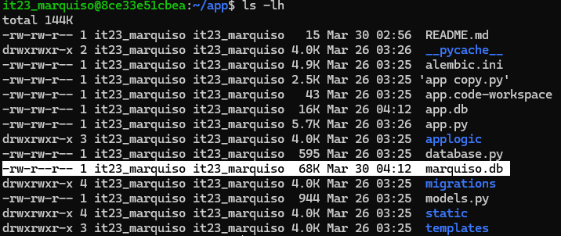
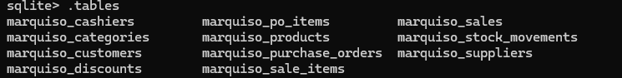

Screenshot 2 — SQLite3 CLI: .schema for All Tables
The student opens marquiso.db using the SQLite3 command-line interface and runs .schema <tablename> for every table. Each schema output must match the SQLAlchemy model definition.



